**FLOOD MONITORING AND EARLY WARNING**

**ABSTRACT**

Floods represent a pervasive and devastating natural hazard with far-reaching consequences for both human lives and infrastructure. This abstract explores the critical importance of flood monitoring and early warning systems in reducing the impact of these disasters. Effective flood management relies on the integration of advanced technologies, including remote sensing, meteorological data, and real-time monitoring networks.

This paper delves into the key components of a comprehensive flood monitoring system, encompassing data collection, analysis, and dissemination. It highlights the significance of accurate and timely data in predicting flood events, allowing authorities to issue early warnings to at-risk populations. Furthermore, the paper discusses the role of community engagement and preparedness in ensuring the effectiveness of such systems.

**INTRODUCTION**

Flood monitoring and early warning systems are crucial components of disaster management, designed to mitigate the devastating impacts of floods. These systems involve the continuous surveillance of various environmental factors, such as rainfall, river levels, and weather conditions, to detect potential flood events. When certain thresholds are exceeded or specific patterns are identified, alerts are issued to authorities and communities at risk, enabling them to take proactive measures to protect lives and property. The effectiveness of flood monitoring and early warning systems relies on advanced technology, real-time data analysis, and efficient communication channels to provide timely and accurate information to those in harm's way, ultimately saving lives and reducing the socio-economic impact of flooding disasters

**DESIGN**

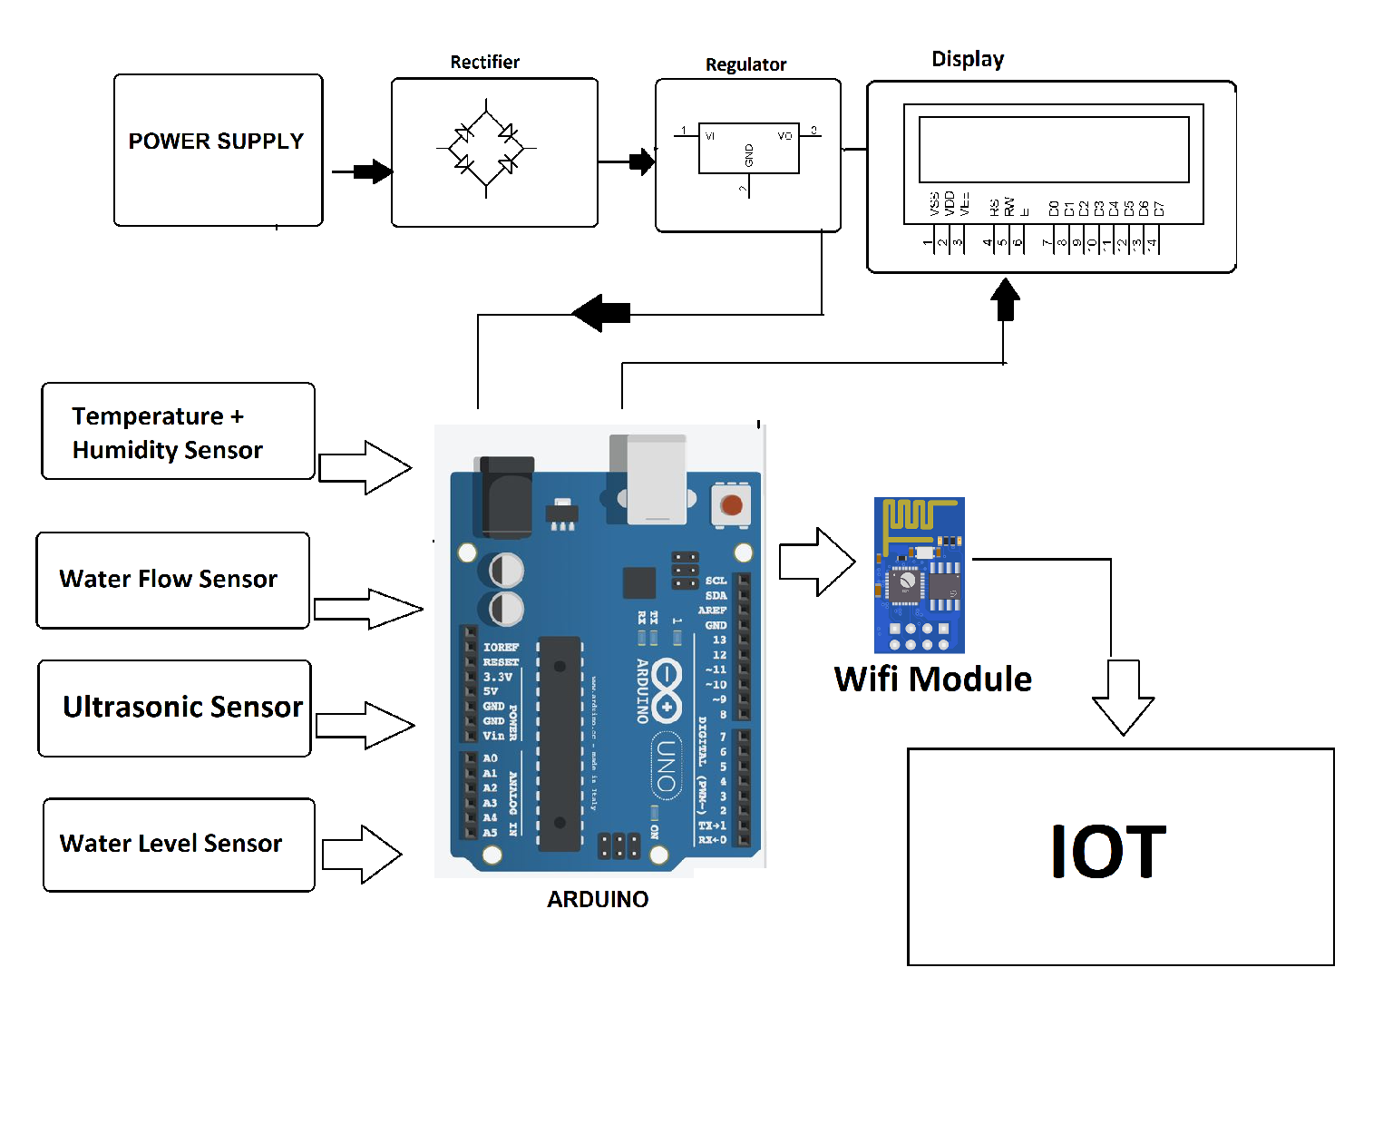

**HARDWARE COMPONENTS**

**.** Power Supply

**.** Node MSU Esp8266

**.** Ultrasonic Sensor HC-SR04

**.** 16×2 LED display

**.** Red LED & Green LED

**.** LM 35 temp

**.** GSM SIM 800L

**.** Arudino UNO

**.** Water level sensor

**1.Arudino UNO**

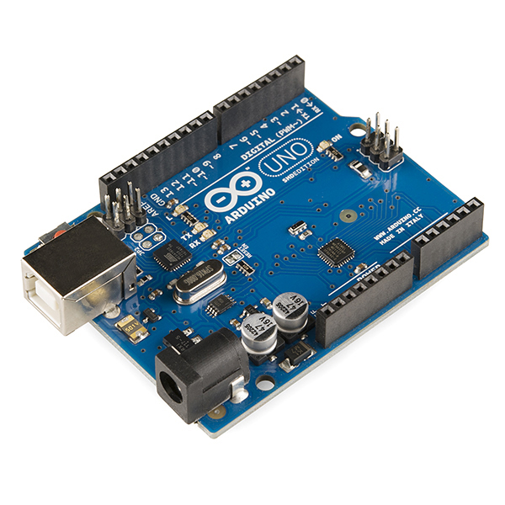

The Arduino Uno is a popular open-source microcontroller board. It is based on the ATmega328P microcontroller and is designed for easy prototyping and development of electronic projects.

The Arduino Uno features digital and analog input/output pins, a USB connection for programming and power supply, and a supportive development environment. It's widely used by hobbyists, students, and professionals for a wide range of applications, from robotics and home automation to interactive art and more. Arduino Uno boards can be programmed using the Arduino IDE (Integrated Development Environment) to control various electronic components and sensors.

**2.Water level sensor**

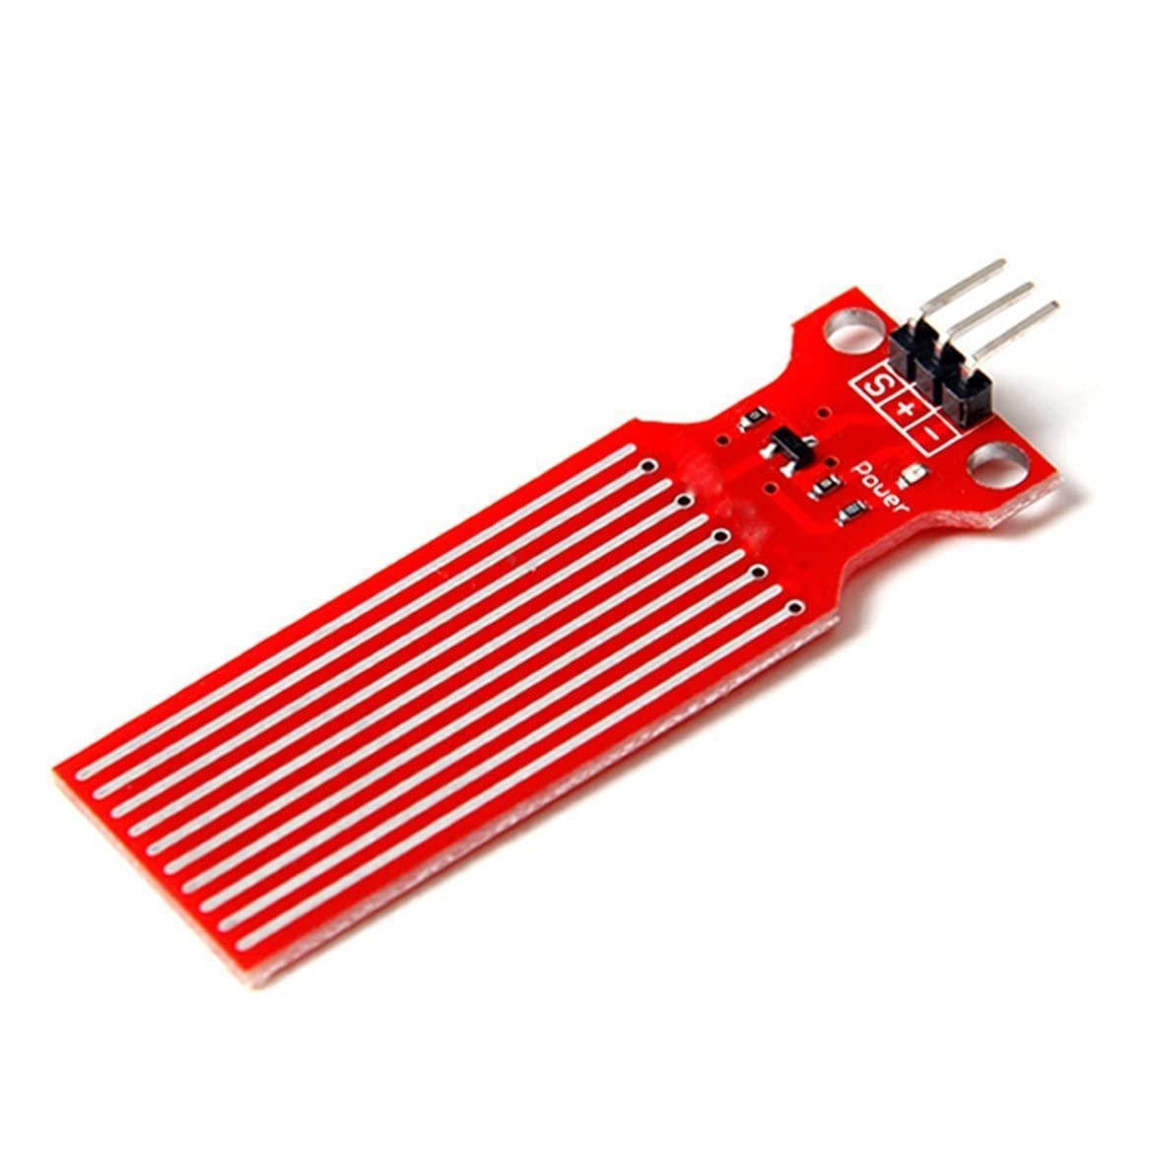

A water level sensor is a device used to measure and monitor the depth or level of water in a tank, reservoir, or any other container. It provides data about the water level, which can be crucial for various applications, such as controlling water pumps, preventing overflow or dry-running of pumps, and automating irrigation systems.

There are different types of water level sensors, including float switches, ultrasonic sensors, capacitance sensors, and pressure sensors. Each type operates using different principles to detect the water level and can be chosen based on the specific requirements of the application.

**3.Ultrasonic Sensor**

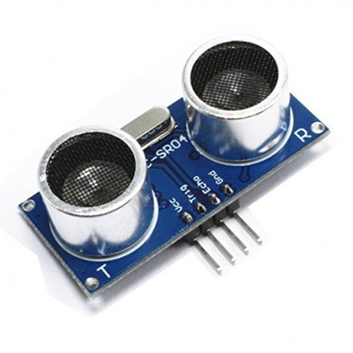

An ultrasonic sensor is a device that uses ultrasonic sound waves to detect the distance or presence of objects. It works by emitting high-frequency sound waves (usually beyond the range of human hearing) and then measuring the time it takes for the sound waves to bounce back after hitting an object. By calculating the time it takes for the sound waves to return, the sensor can determine the distance to the object.

**4.GSM SIM**

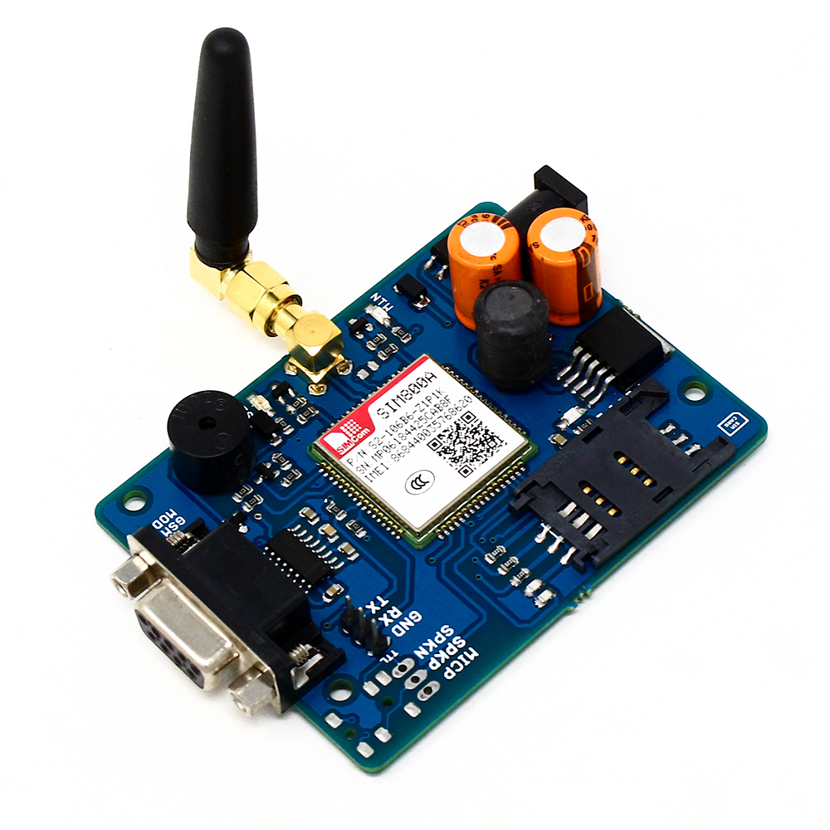

A GSM (Global System for Mobile Communications) module in IoT (Internet of Things) is a hardware component that allows IoT devices to connect to cellular networks. It enables communication between the IoT device and a remote server or control center through the cellular network, making it possible for the device to send and receive data over long distances. GSM modules are commonly used in IoT applications where Wi-Fi or other wired connections are not feasible or reliable. They can be used for various purposes, such as tracking devices, remote monitoring, and control of equipment, and more.

**5.LM 35 temperature sensor**

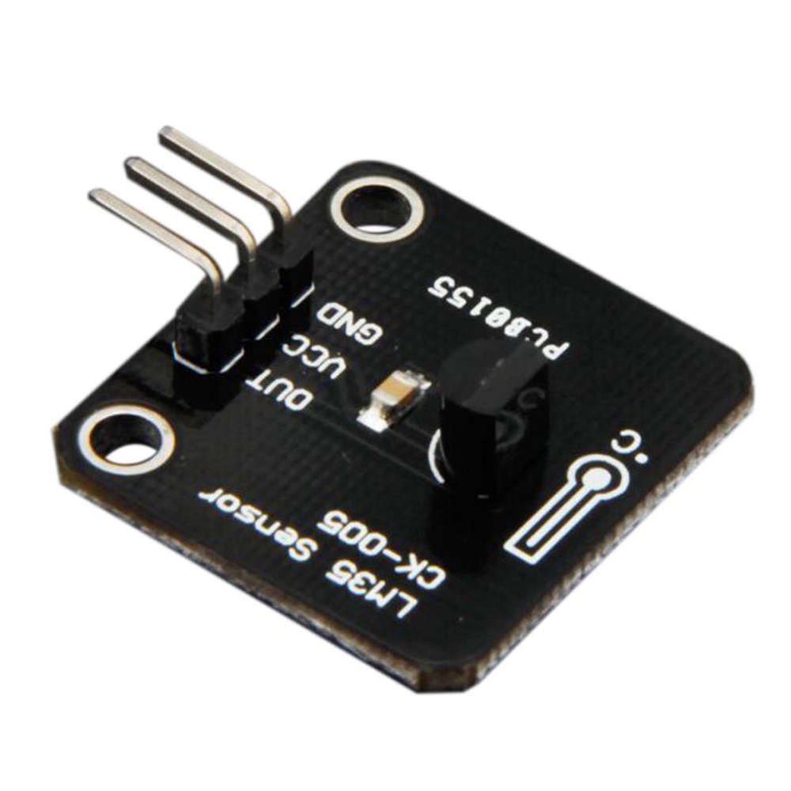

The LM35 is a precision analog temperature sensor IC (integrated circuit) that is commonly used to measure temperature. It provides an analog voltage output that is linearly proportional to the temperature in Celsius, with a scale factor of 10 mV/°C. This means that for every degree Celsius change in temperature, the output voltage of the LM35 changes by 10 millivolts.

The LM35 is often used in various electronic applications and is known for its simplicity and accuracy in measuring temperature. It can be interfaced with microcontrollers, analog-to-digital converters, and other electronic circuits to monitor and control temperature in a wide range of devices and systems.

**TECHNICAL STACK**

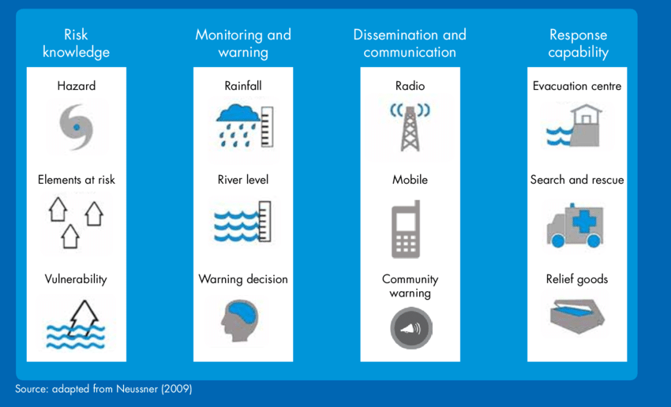

**CONCLUSION**

Flood monitoring is crucial for early warning and disaster management. It involves the use of various technologies like remote sensing, weather forecasts, and river gauges to assess flood risks. Effective flood monitoring can save lives and reduce property damage by providing timely alerts and information to authorities and the public. Continuous advancements in technology and data analysis are improving the accuracy and efficiency of flood monitoring systems, making them increasingly important in the face of climate change and growing urbanization.

**THANK YOU**